**Linear Convolution**

**Code**

x = [1,2,0.5,1]

n1 = 0

h = [1,2,1,-1]

n2 = -1

N1 = size(x,2); // size of x

N2 = size(h,2); // size of h

N = N1+N2-1; // size of final

h2 = flip(h);

n3 = -(N2+n2-1); //starting of -h

ni = n1 + n2;

nf = ni + N - 1;

mstart = n3+ni; // start m

mend = mstart+N-1; // end m

rows = 4+N;

columns = abs(mstart)+mend+N2;

t = zeros(rows, columns);

for i = 1:columns // numbering columns

t(1,i) = mstart+i-1;

end

for i = 1:N1 // filling x

t(2,abs(mstart)+n1+i) = x(i);

end

for i = 1:N2 // filling h

t(3,abs(mstart)+n2+i) = h(i);

end

for i = 1:N2 // filling -h

t(4,abs(mstart)+n3+i) = h2(i);

end

for j = 1:N // filing h in all rows

k=1;

for i = j:j+N2-1

t(j+4,i) = h2(k);

k=k+1;

end

end

t

y=zeros(1,N);

for j = 1:N

for i = 1:N1

y(j) = y(j)+t(2,abs(mstart)+n1+i)*t(4+j,abs(mstart)+n1+i);

end

end

y

ni

subplot(2,2,1);

x1=n1:n1+N1-1;

stem(x1,x);

xlabel('n');

ylabel('x(n)');

title('x(n)');

subplot(2,2,2);

x2=n2:n2+N2-1;

stem(x2,h);

xlabel('n');

ylabel('h(n)');

title('h(n)');

subplot(2,2,3);

x3=n3:n3+N2-1;

stem(x3,h2);

xlabel('n');

ylabel('h(-n)');

title('h(-n)');

subplot(2,2,4);

x4=ni:nf;

stem(x4,y);

xlabel('n');

ylabel('y(n)');

title('y(n) = Linear convolution of x & h');

**Output**

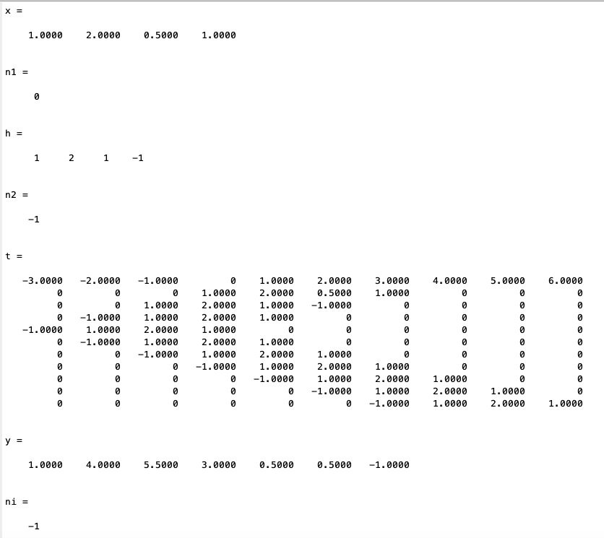

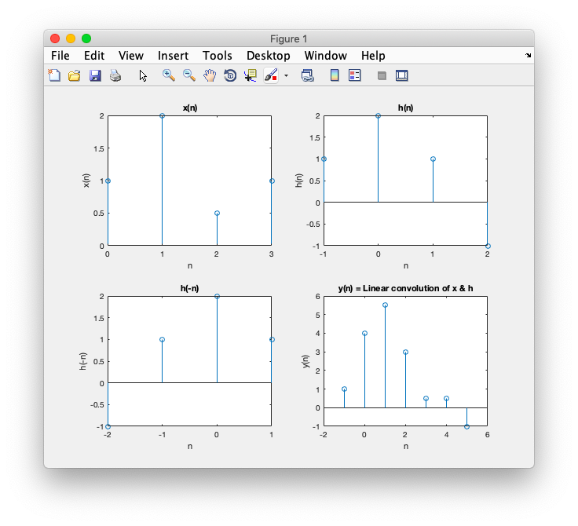

**Circular Convolution**

**Code**

x = [2,1,2,-1]

n1 = 0

h = [1,2,3,4]

n2 = 0

N1 = size(x,2);

N2 = N1;

N = N1;

h2 = flip(circshift(h,N-1));

n3 = 0;

ni = 0;

nf = N-1;

mstart = -(N-1);

mend = N-1;

rows = 3+N;

columns = abs(mstart)+mend+1;

t = zeros(rows, columns);

for i = 1:columns

t(1,i) = mstart+i-1;

end

for i = 1:N

t(2,abs(mstart)+n1+i) = x(i);

end

for i = 1:N

t(3,abs(mstart)+n2+i) = h(i);

end

for j = 1:N

k=1;

for i = j:columns

in = mod(k,N)+1;

t(j+3,i) = h2(in);

k=k+1;

end

end

t

y=zeros(1,N);

for j = 1:N

for i = 1:N

y(j) = y(j)+t(2,i+N-1)*t(3+j,i+N-1);

end

end

y

ni

subplot(2,2,1);

x1=ni:nf;

stem(x1,x);

xlabel('n');

ylabel('x(n)');

title('x(n)');

subplot(2,2,2);

x2=ni:nf;

stem(x2,h);

xlabel('n');

ylabel('h(n)');

title('h(n)');

subplot(2,2,3);

x3=ni:nf;

stem(x3,h2);

xlabel('n');

ylabel('h(-n)');

title('h(-n)');

subplot(2,2,4);

x4=ni:nf;

stem(x4,y);

xlabel('n');

ylabel('y(n)');

title('y(n) = Circular convolution of x & h');

**Output**

